

**TO DEVELOP A PROJECT ON**

**HOUSE RENT APP USING (MERN stack by MongoDB)**

A PROJECT REPORT

*Submitted by*

**RAVI TEJA E - 11052110408**

**FELIX S - 110521104303**

**VIMALESH C - 110521104310**

**VISHAL P - 110521104311**

**ISWARYA M - 110521104701**

*In partial fulfilment for the award of the degree*

*Of*

BACHELOR OF ENGINEERING

IN

DEPARTMENT OF COMPUTER SCIENCE AND ENGINEERING

GOJAN SCHOOL OF BUSINESS AND TECHNOLOGY

ANNA UNIVERSITY, CHENNAI-600 025.

## ABSTRACT :

* This project introduces a robust, MERN stack-based house rental application designed to provide a premium user experience tailored to the unique needs of both property owners and renters. Built with MongoDB, Express.js, React, and Node.js, the application offers a full-stack solution that efficiently streamlines property management and rental processes through a dynamic, user-centric interface. The platform leverages modern development principles and best practices, including microservices architecture, RESTful APIs, and a responsive design, to deliver an application that is scalable, secure, and accessible.
* The property owner’s experience centers on effortless property listing and management. Owners can easily create detailed listings with high-quality photos, video tours, and property descriptions that highlight amenities and key features. The owner dashboard includes an array of tools, such as:

* Property Analytics: Real-time data on property views, rental trends, and occupancy rates provide owners with actionable insights.
* Tenant Management: Owners can view renter profiles, track applications, approve or deny applicants, and manage ongoing tenant interactions within a single platform.
* The renter’s experience is optimized for ease, transparency, and convenience. The application provides a high-quality search feature with filters for location, price, amenities, and lease terms, enabling renters to find the ideal property quickly. Key features for renters include:
* Detailed Listings and Virtual Tours: High-quality listings offer comprehensive property information, virtual tours, and neighborhood insights, providing transparency to support informed decision-making.
* Secure Application and Leasing: Renters can submit applications securely, upload necessary documents, and digitally sign lease agreements.
* Payment Flexibility: Renters can set up secure online payment methods for recurring rent payments, with options for payment reminders and transaction history.
* On the technical side, the MERN stack was chosen for its flexibility, scalability, and extensive ecosystem support. MongoDB provides a highly flexible NoSQL database for efficient data storage and retrieval, particularly useful for managing complex data models.

ABSTRACT : 1

1. EXECUTIVE SUMMARY : 2

2. INTRODUCTION : 2

3. LITERATURE REVIEW : 3

1. Existing Solutions and Market Analysis 3

2. Technologies in Real Estate Applications 4

3. Advantages of Using the MERN Stack for the House Rent Application 4

4. Security and Data Privacy 5

5. Scalability and Future-Proofing 6

4. SCENARIO-BASED CASE STUDY : 6

5. SYSTEM REQUIREMENTS : 7

1. Functional Requirements 7

1.2 Property Listings and Management 8

1.3 Search and Filter Options 8

1.4 Dashboard for Property Owners and Admins 8

1.5 Property Details and User Interaction 8

2. Non-Functional Requirements 8

2.1 Performance 9

2.2 Scalability 9

2.3 Security 9

2.4 Usability and Accessibility 9

2.5 Reliability and Availability 10

2.6 Maintainability 10

3. Technology Requirements 10

Frontend 10

Backend 10

Database 11

Deployment and Hosting 11

Testing and Quality Assurance 11

6. SYSTEM ARCHITECTURE : 11

• MERN Stack Architecture 12

• COMPONENT DIAGRAM : 13

7. DATABASE DESIGN : 13

7.1 E.R DIAGRAM : 13

7.2 APPLICATION OVERVIEW : 14

8. BACKEND DEVELOPMENT : 15

1. Setting Up the Project 16

2. Folder Structure 17

3. Database Setup (MongoDB) 17

4. Controllers (Business Logic) 17

5. Routes (API Endpoints) 17

6. Authentication (Middleware) 17

7. Starting the Server 18

1. config/ 18

2. controllers/ 18

3. middlewares/ 18

8.1 PROJECT STRUCTURE : 18

9 . FRONTEND DEVELOPMENT : 19

1. Setting Up the React Project 21

2. Core Components 21

3. User Pages 21

4. State Management and Context 21

5. API Integration and Services 22

6. Protected Routes and Authorization 22

7. UI/UX Design 22

8. Testing and Debugging 22

10 . USER INTERFACE DESIGN : 23

1. Landing Page / Home Page 23

2. Search Results Page 23

3. Property Details Page 24

4. User Registration and Login Pages 24

5. User Dashboard 24

6. Add/Edit Property Page (for Property Owners) 24

11. KEY FEATURES & FUNCTIONALITY : 25

For Renters: 25

For Property Owners: 25

For Admin: 25

Other capabilities: 25

1. Search and Filtering Capabilities 25

2. Property Listings 26

12. SEARCH AND FILTERING CAPABILITIES : 26

♦ 12.1 SEARCH : 26

♦ 12.2 FILTER OPTIONS : 26

1. For Renters (Users Searching for Properties) 27

2. For Property Owners (Users Listing Properties) 27

13 . DASHBOARD FOR PROPERTY OWNER ,RENTER AND ADMIN : 27

♦ OWNER : 28

♦ ADMIN : 28

♦ RENTER : 28

14 . AUTHENTICATION AND AUTHORIZATION : 29

♦ 14.1 AUTHENTICATION : 29

♦ 14.2 AUTHORIZATION : 29

15 . DEPLOYMENT FOR BACKEND & FRONTEND : 30

GIT EXPLAINATION : 30

1. Tracking and Versioning Code 30

2. Distributed System 30

3. Branches and Merging 31

5. Commit History and Blame Tracking 31

6. Undoing Changes 31

7. Staging Area 31

Why Git is Important 31

15.1 BACKEND DEPLOYMENT : 32

32

15.2 FRONTEND DEPLOYMENT : 32

16 . TESTING AND QUALITY ASSURANCE : 33

1. Requirements Analysis and Test Planning 33

2. Functional Testing 33

3. User Interface (UI) and Usability Testing 34

4. Performance Testing 34

5. Security Testing 34

6. Database Testing 34

7. Regression Testing 35

8. Non-Functional Testing 35

9. Continuous Integration (CI) and Continuous Deployment (CD) 35

17 . CHALLENGES AND SOLUTIONS : 37

1. Scalability 37

2. Data Consistency 38

3. User Authentication and Security 38

4. Search and Filtering Performance 38

5. Cross-Platform Compatibility 38

6. User Experience (UX) 39

7. Payment Processing 39

8. Maintaining Code Quality 39

9. Deployment and DevOps 39

18 . FUTURE ENHANCEMENT : 40

19 . CONCLUSION : 40

20 . REFERENCE : 41

## 1. EXECUTIVE SUMMARY :

The **House Rent Application** is a modern web-based platform developed using the MERN stack (MongoDB, Express.js, React.js, Node.js) to streamline the rental property market. This application aims to bridge the gap between property owners and prospective tenants by providing an intuitive, efficient, and secure platform for property listing, searching, and management.

## 2. INTRODUCTION :

The House Rent Application is a MERN stack-based web app designed to connect property owners with potential tenants. The app allows users to list and search rental properties, manage accounts, and provide seamless interaction between renters and property owners. This report provides an overview of the application, including its features, architecture, and UI/UX design.

**Definition:**

A house rent app is typically a mobile or web application designed to help users find rental properties, apartments, or houses for rent. These apps often offer features to make the process of searching for and renting a property more convenient and efficient. Here are some common features you might find in a house rent app:

* **Property Listings**: The app provides a database of available rental properties, complete with detailed descriptions, photos, location, rent amount, and other relevant information.
* **Search Filters**: Users can apply various filters to narrow down their search results based on criteria such as location, rent range, property type (apartment, house, room, etc.), number of bedrooms, amenities, and more.
* **Contact Landlords/Property Managers**: The app might provide a way for users to contact the property owners or managers directly through the app, often through messaging or email.

## 3. LITERATURE REVIEW :

The **House Renting Application** using the MERN stack builds upon the success and limitations of existing property rental platforms and leverages modern technologies to meet the evolving needs of both property owners and renters. This review examines existing solutions, discusses the role of technology in real estate, and highlights the benefits of using the MERN stack (MongoDB, Express.js, React.js, and Node.js) for this application.

#### **1. Existing Solutions and Market Analysis**

Several well-known platforms like **Zillow**, **Airbnb**, **Realtor.com**, and **Craigslist** dominate the property rental space, each offering unique features to cater to their user base. While these platforms have introduced significant innovation, they often come with limitations and challenges:

* **Zillow** and **Realtor.com** provide robust listings but are primarily focused on property sales, with limited emphasis on rental properties and property management features for owners.
* **Airbnb** excels in short-term rentals and vacation stays but is not tailored for long-term rental listings or property management.
* **Craigslist** allows quick and direct property postings, but the lack of advanced filtering, security, and modern user interface often results in an inconsistent user experience and increased risks for users.

These platforms address specific segments of the rental market but often overlook the needs of long-term rentals or fail to provide flexible management options for property owners. Additionally, most of these platforms rely on monolithic or hybrid architectures, which can be difficult to scale and adapt to new user demands. The **House Rent Application** aims to fill this gap by combining robust property management features with a clean, user-friendly design tailored to long-term rentals.

#### **2. Technologies in Real Estate Applications**

The role of technology in real estate has grown substantially, with a shift from traditional listings to highly interactive, data-driven web applications. According to research in **PropTech** (Property Technology), digital solutions enhance customer engagement, streamline transactions, and improve data accessibility for all stakeholders. Key technological advancements have made it possible for applications to support real-time property updates, complex search functionality, and enhanced data security.

Technologies like **cloud computing**, **NoSQL databases**, and **JavaScript frameworks** allow applications to handle large-scale data operations efficiently, making them ideal for real estate solutions. Additionally, web technologies like **REST APIs** and **microservices** provide flexible data flow between the front end and back end, enabling faster user interactions and seamless application scaling. The adoption of JavaScript frameworks, especially those that support Single Page Applications (SPAs), has greatly improved the user experience by reducing loading times and providing more dynamic, interactive interfaces.

However, a common challenge in real estate applications is the **need for real-time data synchronization** to reflect property availability instantly, ensuring that tenants see only accurate, up-to-date information. Furthermore, security and user privacy have become essential, particularly with respect to handling personal data for bookings, payments, and account management.

#### **3. Advantages of Using the MERN Stack for the House Rent Application**

The **MERN stack** (MongoDB, Express.js, React.js, and Node.js) is well-suited for building a dynamic, data-intensive, and scalable application like a House Rent platform. Below are key advantages of each component and how they contribute to this application's unique needs:

* **MongoDB**: As a NoSQL database, MongoDB stores data in a JSON-like format, making it ideal for handling unstructured and varied data typical in property listings (e.g., images, descriptions, amenities, and user information). MongoDB’s schema-less nature allows easy adaptation and scalability, which is useful as new property features or categories are added. Its ability to handle large data volumes also ensures the platform can scale with more users and property listings over time.
* **Express.js**: This lightweight web application framework provides a robust routing system, which is essential for handling various endpoints such as property listings, user profiles, and search functionalities. Express.js facilitates seamless communication between the front end and MongoDB, efficiently managing data flows while maintaining a secure, API-driven architecture.
* **React.js**: React is a powerful JavaScript library for building user interfaces, particularly Single Page Applications (SPAs). In this House Rent Application, React allows the creation of a responsive, interactive UI that enhances the user experience by providing fast, dynamic interactions with minimal loading times. React’s component-based architecture makes it easy to develop and manage reusable UI elements, such as property cards, search bars, and user dashboards. Furthermore, React’s support for state management and integration with libraries like Redux makes it ideal for managing complex data flows and user interactions across multiple components.
* **Node.js**: As a runtime environment that executes JavaScript on the server side, Node.js enables the House Rent Application to be entirely JavaScript-based, which improves development consistency and performance. Node.js is also asynchronous and event-driven, allowing it to handle multiple simultaneous requests efficiently, which is critical for a real-time application like this one. Node’s non-blocking architecture is particularly beneficial for a platform that requires high performance and scalability, as it can handle requests from a large number of users concurrently.

#### **4. Security and Data Privacy**

Given the nature of real estate applications, security and data privacy are essential. The MERN stack provides several ways to enforce security, from using **JWT (JSON Web Tokens)** for secure user authentication to employing **bcrypt** for password hashing. MongoDB Atlas, the managed database service for MongoDB, also offers end-to-end encryption and advanced security protocols, ensuring user data protection.

With sensitive data like payment information, contact details, and personal information often being exchanged, secure authentication and authorization methods are vital. JWT tokens in the House Rent Application ensure that only authenticated users can access sensitive routes, while MongoDB’s access control and encryption features protect data at rest and in transit. This is crucial in establishing user trust and meeting legal requirements for data protection.

#### **5. Scalability and Future-Proofing**

One of the significant advantages of the MERN stack is its ability to support rapid scaling and future-proofing. As the user base and data grow, MongoDB’s distributed nature can scale horizontally across multiple servers, ensuring consistent performance. Node.js, with its asynchronous event handling, allows the application to manage more requests without requiring additional computational resources. React’s modular, component-based structure also allows for easy updates and new feature integration without overhauling the existing codebase.

The MERN stack thus enables continuous integration and deployment, allowing developers to quickly add features or respond to user feedback, making it adaptable for future demands. This adaptability is critical for a platform like a House Rent Application, which may require rapid updates in response to market trends, new functionalities, or expanded geographies.

4. SCENARIO-BASED CASE STUDY :

1. **User Registration:** Alice, who is looking for a new apartment, downloads your house rent app and registers as a Renter. She provides her email and creates a password.
2. **Browsing Properties:** Upon logging in, Alice is greeted with a dashboard showcasing available rental properties. She can see listings with detailed descriptions, photos, and rental information.She applies filters to narrow down her search, specifying her desired location, rent range, and the number of bedrooms.
3. **Property Inquiry:** Alice finds an apartment she likes and clicks on it to get more information. She sees the property details and owner's contact information.Interested in renting, Alice fills out a small form with her details and sends it to the owner.
4. **Booking Confirmation:** The owner receives Alice's inquiry and reviews her details. Satisfied, the owner approves Alice's booking request.Alice receives a notification that her booking is confirmed, and the status in her dashboard changes to "pending owner confirmation."
5. **Admin Approval (Background Process):** In the background, the admin reviews new owner registrations and approves legitimate users who want to add properties to the app.
6. **Owner Management:** Bob, a property owner, signs up for an Owner account on the app and submits a request for approval.The admin verifies Bob's credentials and approves his Owner account.
7. **Property Management:** With his Owner account approved, Bob can now add, edit, or delete properties in his account.He updates the status and availability of his properties based on their occupancy.
8. **Platform Governance:** Meanwhile, the admin ensures that all users adhere to the platform's policies, terms of service, and privacy regulations.The admin monitors activities to maintain a safe and trustworthy environment for all users.
9. **Transaction and Lease Agreement:** Once Alice's booking is confirmed, she and the owner negotiate the terms of the lease agreement through the app's messaging system.They finalize the rental contract and payment details within the app, ensuring transparency and security.
10. **Move-in Process:** Alice successfully moves into her new apartment, marking the completion of the rental process facilitated by the house rent app.This scenario highlights the main functionalities of your MERN-based house rent app, including user registration, property browsing, inquiry and booking process, admin approval, owner management, platform governance, and the overall rental transaction.

## 5. SYSTEM REQUIREMENTS :

The **House Rent Application** requires a robust, scalable, and secure setup to handle diverse user roles and a dynamic data environment. Below are the detailed system requirements, broken down into **functional** and **non-functional requirements**.

### **1. Functional Requirements**

The functional requirements outline essential features and operations of the application, focusing on what the system should perform to meet the needs of tenants, property owners, and administrators.

**1.1 User Management and Authentication**

* **Registration and Login**: Users (tenants, property owners, and admins) should be able to register and log in securely.
* **Role-Based Access Control (RBAC)**: The application should distinguish between three types of users—tenant, property owner, and admin—with specific permissions for each role:
  + **Tenant**: Can search and view property listings, contact owners, and save properties to favorites.
  + **Property Owner**: Can add, update, and delete property listings, view analytics, and respond to tenant inquiries.
  + **Admin**: Has full control over user management, property listings, and the ability to monitor platform usage.

#### **1.2 Property Listings and Management**

* **Property Addition and Editing**: Property owners should be able to add new properties with details like location, rent, amenities, images, and property type (apartment, house, etc.).
* **Listing Updates**: Owners should be able to edit and update listings as needed.
* **Property Deletion**: Owners can remove a listing if it is no longer available.

#### **1.3 Search and Filter Options**

* **Search Functionality**: Tenants should be able to search for properties using keywords.
* **Filtering Options**: Allow filtering by price range, location, property type, and amenities.
* **Sorting Options**: Enable sorting by price, newest listings, and proximity to user location.

#### **1.4 Dashboard for Property Owners and Admins**

* **Owner Dashboard**: Property owners should have access to a dashboard displaying property listings, analytics (such as views and inquiries), and contact information for interested tenants.
* **Admin Dashboard**: Admins should be able to view platform statistics, manage users and listings, monitor content for quality, and handle reports or complaints.

#### **1.5 Property Details and User Interaction**

* **Property Detail Page**: Display detailed property information, images, and contact details for the property owner.
* **Favorites and Bookmarking**: Tenants should be able to save listings for future reference.
* **Contact and Inquiry System**: Tenants should be able to contact property owners directly via an inquiry form.

### **2. Non-Functional Requirements**

The non-functional requirements detail the system's quality attributes, including performance, scalability, security, and usability.

#### **2.1 Performance**

* **Response Time**: The application should have a response time of less than 2 seconds for user actions like login, search, and filtering.
* **Data Loading Speed**: Property listings and images should load quickly and efficiently, especially on the homepage and search results.
* **Concurrent Users**: The system should support at least 1,000 concurrent users, with the ability to scale up as needed.

#### **2.2 Scalability**

* **Horizontal Scalability**: The application should be able to scale horizontally to handle an increasing number of users and property listings.
* **Data Scalability**: MongoDB’s sharding and replication features should be used to scale the database as the number of properties and users grows.
* **Microservices Support**: The application should be designed to support a microservices architecture in the future, allowing features to be independently developed and scaled.

#### **2.3 Security**

* **User Authentication**: Implement secure user authentication using JWT (JSON Web Tokens) and bcrypt for password hashing.
* **Data Encryption**: Sensitive data, such as passwords and user contact details, should be encrypted in transit and at rest.
* **Role-Based Authorization**: Ensure that only users with the correct permissions can access specific functionalities (e.g., only admins can delete user accounts).
* **Data Validation and Sanitization**: Prevent SQL injection, XSS attacks, and other security vulnerabilities by validating and sanitizing all user inputs.

#### **2.4 Usability and Accessibility**

* **User-Friendly Interface**: Provide a simple, clean, and intuitive interface that makes it easy for tenants and owners to navigate and perform actions.
* **Responsive Design**: Ensure the application is fully responsive and accessible on desktops, tablets, and mobile devices.
* **Accessibility Standards**: Follow WCAG guidelines to make the application accessible to users with disabilities, including support for screen readers and keyboard navigation.

#### **2.5 Reliability and Availability**

* **Data Backups**: Implement regular data backups for MongoDB to ensure data recovery in case of failures.
* **Server Uptime**: The application should have at least 99.9% uptime, with provisions for handling downtime and failures.
* **Fault Tolerance**: Ensure redundancy in critical components, especially for the database, to minimize downtime and prevent data loss.

#### **2.6 Maintainability**

* **Code Modularity**: Follow modular coding practices with separate components for frontend and backend, making it easier to update or replace features.
* **Documentation**: Maintain comprehensive documentation for code, APIs, and deployment processes, allowing future developers to understand and extend the application efficiently.
* **Automated Testing**: Implement automated testing for key features to ensure functionality during updates or changes to the codebase.

### **3. Technology Requirements**

#### **Frontend**

* **Framework**: React.js
* **UI Libraries**: Material-UI or Bootstrap for reusable components and styling
* **State Management**: Redux or Context API for managing global state
* **API Requests**: Axios or Fetch for handling HTTP requests to the backend

#### **Backend**

* **Runtime**: Node.js for the server environment
* **Framework**: Express.js for handling routing and middleware
* **Authentication**: JSON Web Tokens (JWT) for user authentication
* **Data Validation**: Joi or validator.js for server-side data validation

#### **Database**

* **Database**: MongoDB for flexible, schema-less data storage
* **Deployment**: MongoDB Atlas for a managed, cloud-based solution
* **ORM/ODM**: Mongoose for modeling and managing MongoDB data in Node.js

#### **Deployment and Hosting**

* **Cloud Provider**: AWS, Heroku, or DigitalOcean for hosting the application
* **Frontend Hosting**: Vercel or Netlify for hosting the frontend React application
* **Continuous Integration/Continuous Deployment (CI/CD)**: GitHub Actions or Jenkins for automating build and deployment processes

#### **Testing and Quality Assurance**

* **Frontend Testing**: Jest and React Testing Library for unit and integration tests
* **Backend Testing**: Mocha and Chai for API testing
* **End-to-End Testing**: Cypress or Selenium to test full workflows

## 6. SYSTEM ARCHITECTURE :

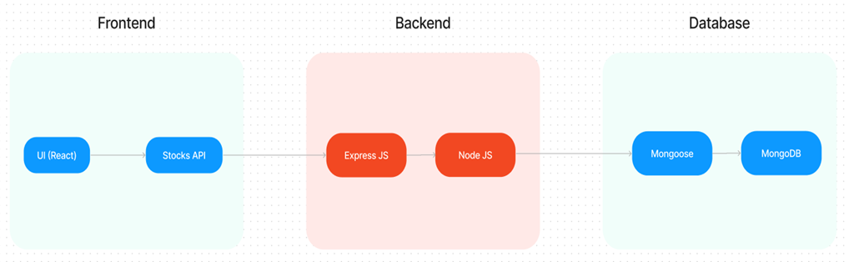

The technical architecture of our House rent app follows a client-server model, where the frontend serves as the client and the backend acts as the server. The frontend encompasses not only the user interface and presentation but also incorporates the axios library to connect with backend easily by using RESTful Apis.

The frontend utilizes the bootstrap and material UI library to establish real-time and better UI experience for any user whether it is admin, doctor and ordinary user working on it.

On the backend side, we employ Express.js frameworks to handle the server-side logic and communication.

For data storage and retrieval, our backend relies on MongoDB. MongoDB allows for efficient and scalable storage of user data, including user profiles, for booking room, and adding room, etc. It ensures reliable and quick access to the necessary information.

Together, the frontend and backend components, along with moment, Express.js, and MongoDB, form a comprehensive technical architecture for our House rent app. This architecture enables real-time communication, efficient data exchange, and seamless integration, ensuring a smooth and immersive booking an appointment and many more experience for all users.

### **MERN Stack Architecture**

The **MERN Stack** is a popular JavaScript stack used for building dynamic web applications. It comprises **MongoDB**, **Express.js**, **React.js**, and **Node.js**. These four technologies work together to allow developers to build complete, end-to-end applications entirely in JavaScript, making development more efficient and cohesive. Below is a detailed breakdown of each component and how they interact within the architecture of a MERN application.

The application is built using the following layered architecture:

1. **Frontend** (React): Handles the client-side logic, rendering UI components, and managing the application state.
2. **Backend** (Node & Express): Handles REST API requests, authentication, and business logic.
3. **Database** (MongoDB): Stores user data, property listings, and favorite properties.

* **Key Benefits of MERN Architecture**
* **End-to-End JavaScript**: MERN allows for consistent use of JavaScript across the entire stack, simplifying development and making it easier to share code between frontend and backend.
* **Scalability and Performance**: MongoDB and Node.js are built for scalable, high-performance applications. MongoDB’s distributed database model and Node’s non-blocking I/O operations enable efficient handling of high traffic and large data loads.

Below is a sample report structure for the **House Rent Application** using the MERN stack, incorporating images and the technical structure we discussed.

## COMPONENT DIAGRAM :

User Interface (React)  
 |  
 |  
 Backend Server (Node.js & Express.js) ----> MongoDB Database  
 |  
 |  
 API Gateway (REST API)

## 7. DATABASE DESIGN :

### 7.1 E.R DIAGRAM :

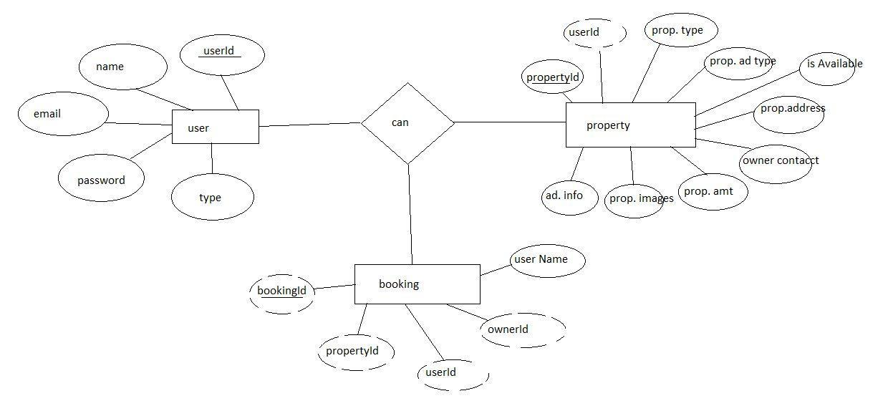

Here there is 3 collections namely users, property, and booking which have their own fields in

Users:

1. _id: (MongoDB creates by unique default)
2. name
3. email
4. password
5. Type

Property:

1. userID: (can be act as foreign key )
2. _id: (MongoDB creates by unique default)
3. prop.Type
4. prop.AdType
5. isAvailable
6. prop.Address
7. owner contact
8. prop.Amt
9. prop.images
10. add.Info

Booking

1. _id: (MongoDB creates by unique default)
2. propertId
3. userId
4. ownerId
5. username

## 7.2 APPLICATION OVERVIEW :

* **Database**:

MongoDB for storing user and property data

* **Authentication**:

JWT for secure authentication

* **Deployment**:

Cloud hosting (AWS, DigitalOcean, or similar)

Here are the tools required for developing a full-stack application using Node.js, Express.js, MongoDB, React.js:

* **Node.js and npm:** Node.js is a powerful JavaScript runtime environment that allows you to run JavaScript code on the server-side. It provides a scalable and efficient platform for building network applications.
* **Express.js:** Express.js is a fast and minimalist web application framework for Node.js. It simplifies the process of creating robust APIs and web applications, offering features like routing, middleware support, and modular architecture. Install Express.js, a web application framework for Node.js, which handles server-side routing, middleware, and API development.
* **MongoDB:** MongoDB is a flexible and scalable NoSQL database that stores data in a JSON-like format. It provides high performance, horizontal scalability, and seamless integration with Node.js, making it ideal for handling large amounts of structured and unstructured data.
* **Moment.js:** Momentjs is a JavaScript package that makes it simple to parse, validate, manipulate, and display date/time in JavaScript. Moment. js allows you to display dates in a human-readable format based on your location. Install React.js, a JavaScript library for building user interfaces.
* **React.js:** React.js is a popular JavaScript library for building user interfaces. It enables developers to create interactive and reusable UI components, making it easier to build dynamic and responsive web applications. Install React.js, a JavaScript library for building user interfaces.
* **Antd:** Ant Design is a React. js UI library that contains easy-to-use components that are useful for building interactive user interfaces. It is very easy to use as well as integrate. It is one of the smart options to design web applications using react.
* **HTML, CSS, and JavaScript**: Basic knowledge of HTML for creating the structure of your app, CSS for styling, and JavaScript for client-side interactivity is essential.
* **Database Connectivity**: Use a MongoDB driver or an Object-Document Mapping (ODM) library like Mongoose to connect your Node.js server with the MongoDB database and perform CRUD (Create, Read, Update, Delete) operations.
* **Front-end Framework**: Utilize Reactjs to build the user-facing part of the application, including entering booking room, status of the booking, and user interfaces for the admin dashboard. For making better UI we have also used some libraries like material UI and boostrap.

### 8. BACKEND DEVELOPMENT :

The backend for this projectusing the MERN stack is responsible for handling data storage, business logic, authentication, and API endpoints that serve data to the frontend. This section outlines how to set up and implement the backend using **Node.js** with **Express.js** as the framework, **MongoDB** as the database, and **Mongoose** for data modeling.

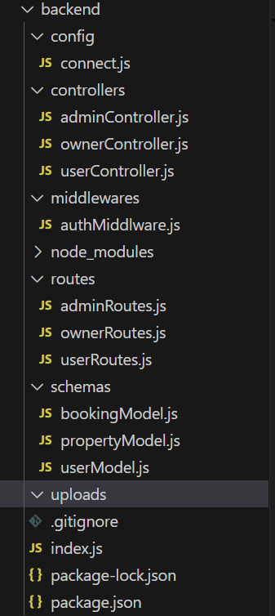

* This is the structure of backend that consists of JAVASCRIPT and JSON packages. These structure mainly based on configuration , controllers , middleware , node_modules that conists of modules to desgin and make the web page more effective , routes, schemas of javascript, uploads of version controls like “GIT”.
* The structure for this backend services and packages is given below the diagramatic representation .

Here’s a simplified breakdown:

#### **1. Setting Up the Project**

* **Initialize the Project**: Start by creating a folder for the project, then initialize it as a Node.js project. Install required libraries like **Express** (for server), **Mongoose** (to work with MongoDB), **JWT** (for user authentication), and **Bcrypt** (to encrypt passwords).
* **Environment Configuration**: Use a .env file to securely store sensitive data, like your MongoDB connection string and JWT secret key.

#### **2. Folder Structure**

* **Organized Folders**: Create folders for **models** (database schemas), **controllers** (logic for handling data), **routes** (API endpoints), and **middleware** (authentication checks).
* **Main Files**: Each folder will contain files for specific functions, like userController.js for user logic and propertyController.js for property listings.

#### **3. Database Setup (MongoDB)**

* **Connection**: Use **Mongoose** to connect to MongoDB, which will store user details, property listings, and more.
* **Data Models**: Define schemas for data storage. For example, a **User model** has fields like name, email, password, and role (tenant or owner). A **Property model** stores details about rental properties like title, description, price, and owner.

#### **4. Controllers (Business Logic)**

* **User Controller**: Handles user actions like **registration** (stores encrypted password) and **login** (validates user and returns a JWT token).
* **Property Controller**: Handles creating, reading, and updating property listings. Only authenticated users can create listings.

#### **5. Routes (API Endpoints)**

* **User Routes**: Routes handle requests for user actions, like /register and /login, which go to userController functions.
* **Property Routes**: Routes like /properties enable users to view, create, or manage property listings.

#### **6. Authentication (Middleware)**

* **JWT Middleware**: JWT (JSON Web Token) is used for secure authentication. Middleware checks if a user has a valid token before accessing protected routes (e.g., creating a property listing).

#### **7. Starting the Server**

* **Express Server**: In the main file, server.js, initialize Express, connect to MongoDB, set up middleware, and define routes. The server listens on a specified port, ready to handle API requests.

### **1. config/**

* **connect.js**: This file typically contains the code to establish a connection to the **MongoDB** database. It would use Mongoose to connect to the database using credentials stored in environment variables.

### **2. controllers/**

* This folder contains files for handling various types of user roles and their operations:
  + **adminController.js**: Manages the logic related to administrative tasks. This could include managing users, viewing all bookings, or managing property listings.
  + **ownerController.js**: Handles actions specific to property owners, such as creating, updating, and deleting property listings. It might also include viewing bookings made on their properties.
  + **userController.js**: Manages general user-related actions, like user registration, login, profile updates, and booking properties.

### **3. middlewares/**

* **authMiddleware.js**: Middleware is code that runs before certain requests. Here, the authMiddleware.js file likely checks if a user is authenticated (using a JSON Web Token, or JWT) and may verify their role (e.g., admin, owner, or regular user). It ensures that only authorized users can access certain routes.

## 8.1 PROJECT STRUCTURE :

Organize the backend project into a structured format for scalability and maintainability:

house-rent-backend/

├── config/

│ └── db.js # MongoDB connection setup

├── controllers/

│ └── userController.js # User-related logic

│ └── propertyController.js # Property-related logic

├── models/

│ └── User.js # User model

│ └── Property.js # Property model

├── routes/

│ └── userRoutes.js # User routes

│ └── propertyRoutes.js # Property routes

├── middleware/

│ └── auth.js # Middleware for JWT verification

├── .env # Environment variables

├── server.js # Entry point of the application

└── package.json

## 9 . FRONTEND DEVELOPMENT :

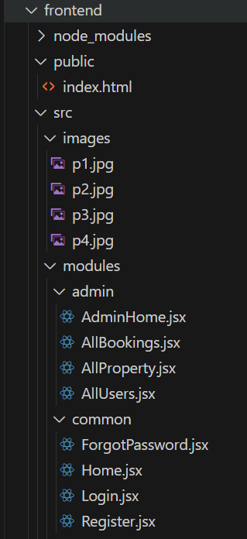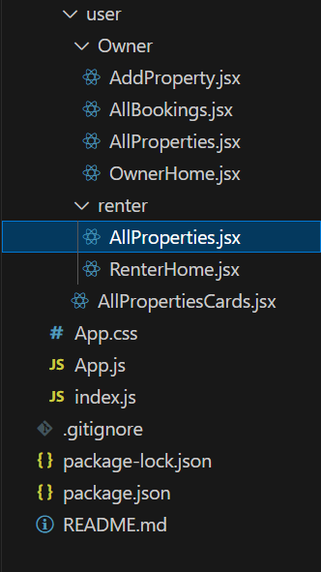

* This is mainly based on Frontend packages of web page that is forms to register , sign_up , relink , booking , login . Its’s mostly consists of node_module , public , source : images of properties , modules for admin common login page needs like Home , Login , Register , Forgotpassword , User : owner , renter , others are based on Backend structure.

The frontend of a **House Rent Application** using the **MERN stack** is built with **React.js** to create a dynamic, user-friendly interface. React handles the **view layer** of the application, providing responsive pages and components that display property listings, handle user inputs, and interact with backend APIs. Here’s a breakdown of the main components involved in frontend development for this type of application.

#### **1. Setting Up the React Project**

* **Project Initialization**: Start by setting up a React project using tools like **Create React App**. This creates the base project structure and configures dependencies needed for building the UI.
* **Folder Structure**: Organize the project into folders for **components** (individual UI pieces), **pages** (main views like Home or Dashboard), **context** (for state management), **services** (for API calls), and **assets** (for images, styles).

#### **2. Core Components**

* **Header & Navigation**: Create a **Header** component with navigation links for users to browse properties, log in, register, and view their profile or dashboard.
* **Property List**: Design a **PropertyList** component that displays property listings in a grid or list format. Each property card should include an image, title, price, and a "View Details" button.
* **Property Details**: A **PropertyDetails** component shows detailed information for a selected property, including images, description, and contact information for the owner.
* **Search and Filter**: Add a **SearchBar** and filter options (e.g., location, price range) to help users find specific properties. This component interacts with the backend to retrieve filtered results.

#### **3. User Pages**

* **Registration & Login**: Design forms for **Register** and **Login** pages, where users can create accounts or log in. On successful login, a **JWT token** is saved in the client (e.g., in local storage) for authentication on protected routes.
* **User Dashboard**: Create a **Dashboard** for property owners and tenants, displaying their information. Property owners can view, edit, or delete their listings, while tenants can see properties they've saved or contacted.

#### **4. State Management and Context**

* **Global State**: Use **React Context** or **Redux** to manage global state for authentication, user data, and property listings. This ensures that user information is accessible across different pages without passing data through each component.
* **User Authentication State**: Manage authentication state globally so the app knows if a user is logged in and can render the appropriate views (like showing “My Account” instead of “Login”).

#### **5. API Integration and Services**

* **API Service Layer**: Create a service layer that defines functions for interacting with backend API endpoints. For example, fetchProperties, createProperty, loginUser, and registerUser.
* **Asynchronous Requests**: Use **Axios** or the native fetch API to make requests. For instance, on login, send a POST request to the backend and store the JWT token in local storage if the login is successful.

#### **6. Protected Routes and Authorization**

* **Route Protection**: Use a combination of React Router and authentication logic to protect certain routes (e.g., dashboard or property management pages) so only authenticated users can access them.
* **Role-Based Access**: Implement role-based views to control what users see based on their roles. For example, property owners see options to manage listings, while tenants see options to browse or contact owners.

#### **7. UI/UX Design**

* **Responsive Design**: Ensure that the app is fully responsive across devices, with mobile-first design principles. Use libraries like **Bootstrap** or **Material-UI** to speed up development and ensure consistency.
* **Loading States and Feedback**: Add loading spinners, error messages, and success notifications to provide feedback during operations, like property searches or user login attempts.
* **Image and Content Optimization**: Optimize images and use lazy loading to ensure the app performs well, especially on pages with multiple property listings.

#### **8. Testing and Debugging**

* **Component Testing**: Use tools like **Jest** and **React Testing Library** to test components, ensuring that buttons, forms, and interactions work as expected.
* **End-to-End Testing**: Test workflows like registration, login, and property search from start to finish. This helps catch issues in user experience or with API integration.
* **Debugging and Error Handling**: Use browser DevTools to debug UI issues and test error handling for network requests, such as showing appropriate error messages when the server is unavailable.

## 10 . USER INTERFACE DESIGN :

Designing the **User Interface** (UI) for a house rental app involves creating a clean, intuitive, and visually appealing experience that allows users to seamlessly browse, search, and manage rental properties. In this app, **React.js** is used as the front-end framework to build the dynamic UI. Here’s an outline of the key pages and components in the UI design, along with their functionalities and layout.

#### **1. Landing Page / Home Page**

* **Hero Section**: Features a large banner image related to real estate, with a prominent search bar to look for properties based on location, price, and property type.
* **Property Categories**: Quick links to different types of properties (e.g., apartments, houses, studios) or locations.
* **Featured Properties**: A section showcasing popular or recently listed properties with thumbnails, brief descriptions, and prices.
* **How It Works Section**: Short explanation of how the app works, such as browsing properties, booking a place, and contacting owners.
* **Footer**: Contains links to About, Contact, and Support pages, as well as social media icons and copyright information.

#### **2. Search Results Page**

* **Search Filters**: Provides options to filter by location, price range, number of bedrooms, and other amenities. Filters are usually displayed in a sidebar or above the results.
* **Property Listings**: Displays a list or grid of properties based on the search criteria, each with a small image, title, location, price, and a “View Details” button.
* **Map View Option**: Option to switch to a map view where users can see property locations on a map. Each property can be represented by a pin on the map for easy navigation.

#### **3. Property Details Page**

* **Image Gallery**: A carousel of property images to give users a detailed look at the property.
* **Property Information**: Displays the property’s title, description, price, location, and available dates.
* **Amenities**: List of available amenities, like Wi-Fi, parking, air conditioning, etc.
* **Booking Section**: Includes a date picker for choosing check-in and check-out dates, along with a button to book the property.
* **Owner Contact Information**: Allows the user to contact the property owner for questions or additional details.
* **Map Section**: Displays a small map with the property location for reference.

#### **4. User Registration and Login Pages**

* **Login Form**: Form for users to log in using their email and password. Optionally, social login (Google, Facebook) can be added.
* **Registration Form**: Form to create a new account with fields for name, email, password, and role (tenant or property owner).
* **Password Reset Option**: Link to reset the password, which sends a reset link to the user’s email.

#### **5. User Dashboard**

* **For Tenants**:
  + **Saved Properties**: Displays properties that the user has bookmarked for later viewing.
  + **Booking History**: Shows the list of previous and upcoming bookings, including booking dates, property details, and total cost.
* **For Property Owners**:
  + **Manage Properties**: Shows a list of properties the owner has listed. Owners can add, edit, or delete property listings.
  + **Booking Requests**: Displays any requests made by tenants to book the owner’s properties, including the option to approve or decline bookings.
* **User Profile Settings**: Allows users to update their personal information, contact details, and password.

#### **6. Add/Edit Property Page (for Property Owners)**

* **Property Form**: Form to input all necessary information about the property, such as title, description, price, location, and available dates.
* **Image Upload**: Section to upload multiple images of the property, which will be displayed in the image gallery.
* **Amenities Selection**: Options for selecting available amenities, such as air conditioning, Wi-Fi, parking, etc.
* **Save Changes Button**: Allows the owner to save the information and add it to their listings, or update an existing listing.

The UI design for the house rental app in the MERN stack combines essential features for easy property browsing, efficient booking, and user account management. React enables a responsive and modular component-based UI, making the interface scalable and interactive.

## 11. KEY FEATURES & FUNCTIONALITY :

### **For Renters:**

* **View Listings**: Browse all available rental properties.
* **Filter Options**: Narrow down listings by location, price, and property type.
* **Property Details**: Access in-depth property information, including images, description, and owner contact info.
* **Favorite Listings**: Save favorite properties for later reference.

### **For Property Owners:**

* **Property Management**: List properties with detailed descriptions and images.
* **Edit & Delete Listings**: Update or remove properties as needed.

### **For Admin:**

* **User Management**: Manage all users on the platform.
* **Property Management**: Access and manage all listings.

### Other capabilities:

### **Search and Filtering Capabilities**

* **Search Bar**: Allows users to search properties by location or keywords.
* **Filter Options**: Users can filter properties by various criteria, such as:
  + Price range
  + Property type (e.g., apartment, house)
  + Number of bedrooms/bathrooms
  + Availability dates
  + Amenities (e.g., pet-friendly, furnished)
* **Sort Functionality**: Allows sorting properties by price, rating, or newest listings for easy browsing.

### **2. Property Listings**

* **Add/Edit Property**: Property owners can add new listings with details like title, description, price, location, and available dates.
* **Image Upload**: Owners can upload images of their properties, which are stored and displayed in an image gallery to give tenants a visual preview.
* **Amenities Selection**: Owners can specify amenities (e.g., Wi-Fi, parking, air conditioning), making it easier for tenants to search for properties with specific features.

## 12. SEARCH AND FILTERING CAPABILITIES :

### 12.1 SEARCH :

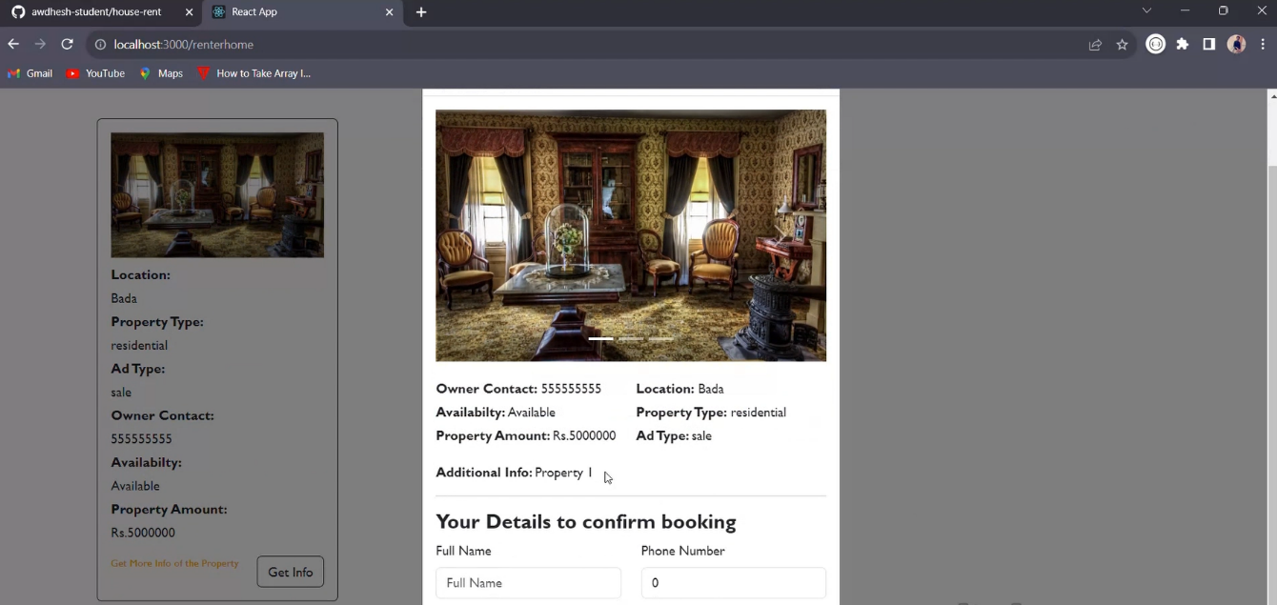

* This is used to search for the specification of rental houses and location for perfectual areas to choose with the customer choices.

## 12.2 FILTER OPTIONS :

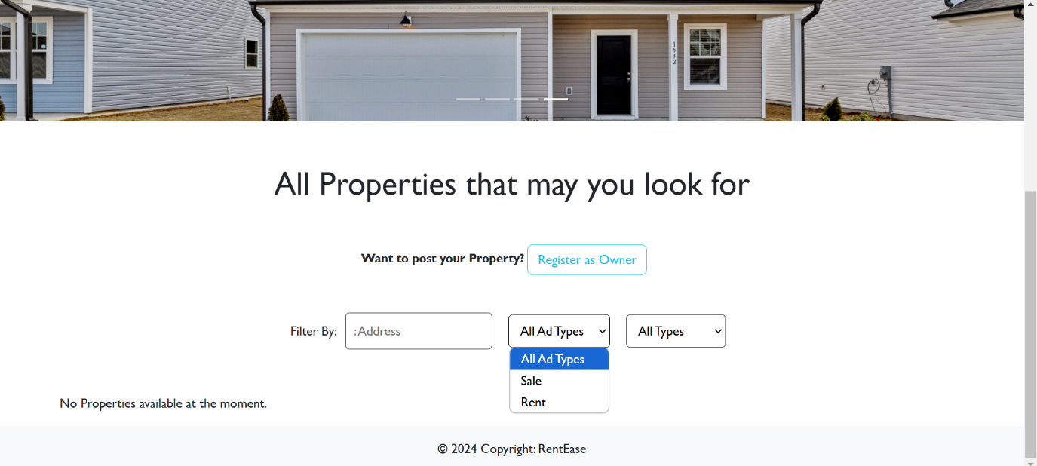

* In this filter option the renter can add sales and rent types of ad types , and they can also flexiblily use the address option to filter out the nearby areas or homes they are looking after .

The **search and filter feature** in a house rental app is used to enhance the user experience by allowing renters to quickly find properties that meet their specific needs and preferences. Here’s how each user group benefits:

### **1. For Renters (Users Searching for Properties)**

* **Efficient Searching**: Renters can enter criteria such as location, price range, number of bedrooms, and specific amenities (e.g., pet-friendly, parking availability). This narrows down the results to properties that best match their requirements.
* **Improved Decision-Making**: By filtering results based on personal preferences, renters can make more informed decisions and save time by focusing only on relevant listings.

### **2. For Property Owners (Users Listing Properties)**

* **Increased Visibility**: Listings are more likely to appear to potential renters looking for specific features, like proximity to a city center, certain amenities, or a particular property type.

## 13 . DASHBOARD FOR PROPERTY OWNER ,RENTER AND ADMIN :

### OWNER :

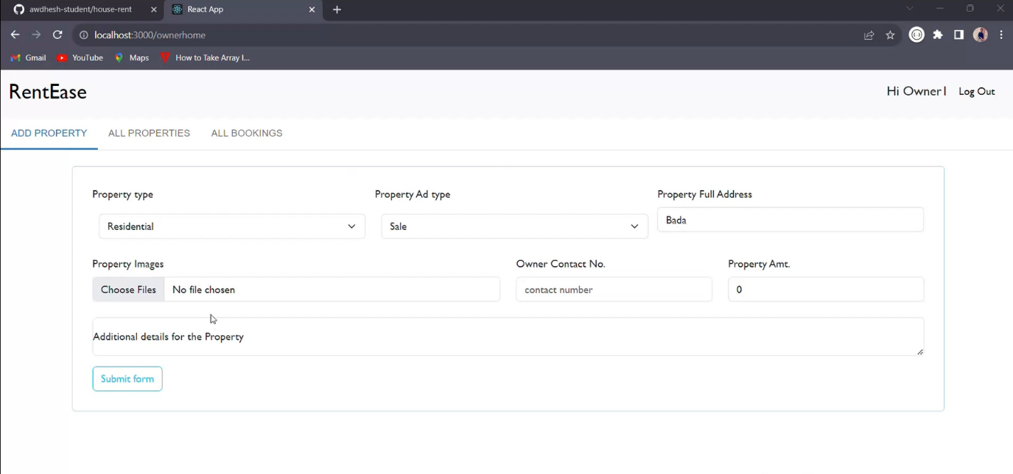

* In the above image the property owner is logining in the owner page for updating the property details , to add new property with the existing property details , to clean up the granted property details by the admin of the webpage .

### ADMIN :

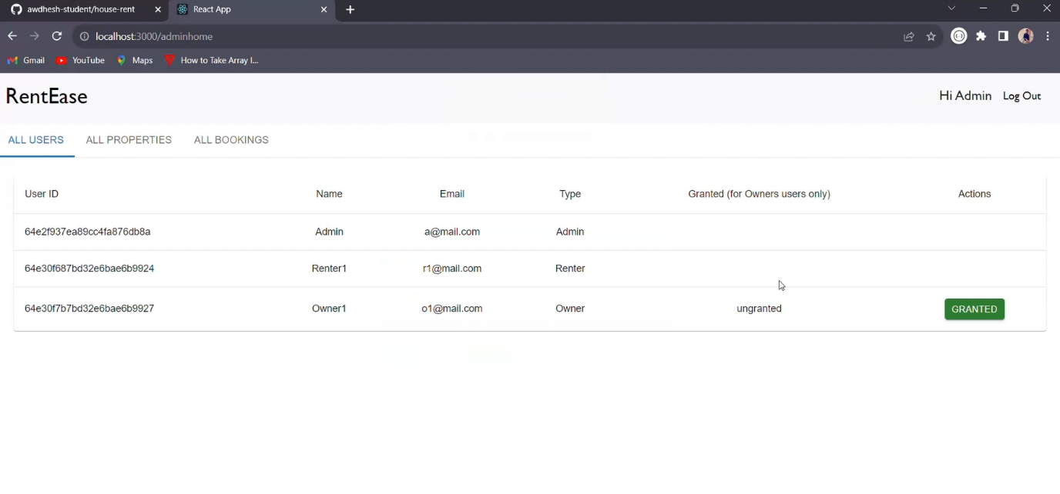

* The above image represents of admin login page to access the admin page for granting the access to property and to remove delayed property from the web page to new customers and services for better experience.

### RENTER :

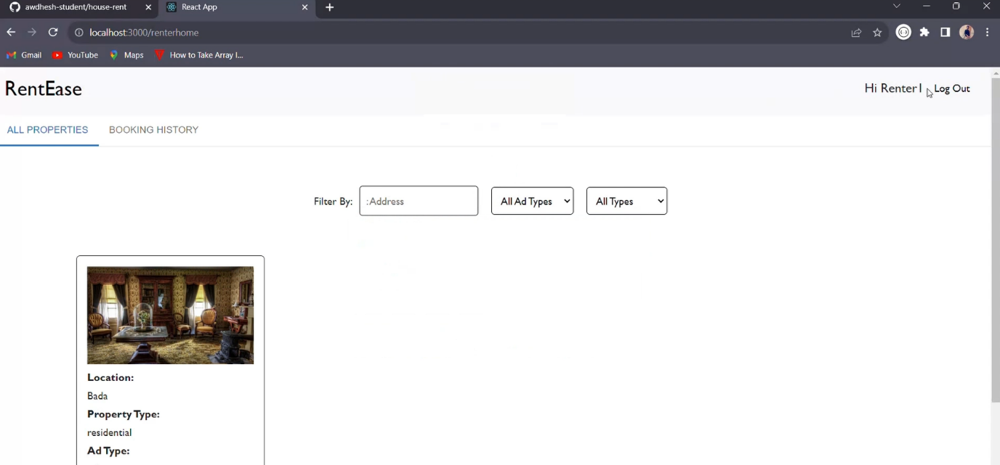

* The above image shows the renter dashboard with the greetings of “HI RENTER” it is formally used by only the common renters and other peoples to look for the preferred home or available rental places .

## 14 . AUTHENTICATION AND AUTHORIZATION :

### 14.1 AUTHENTICATION :

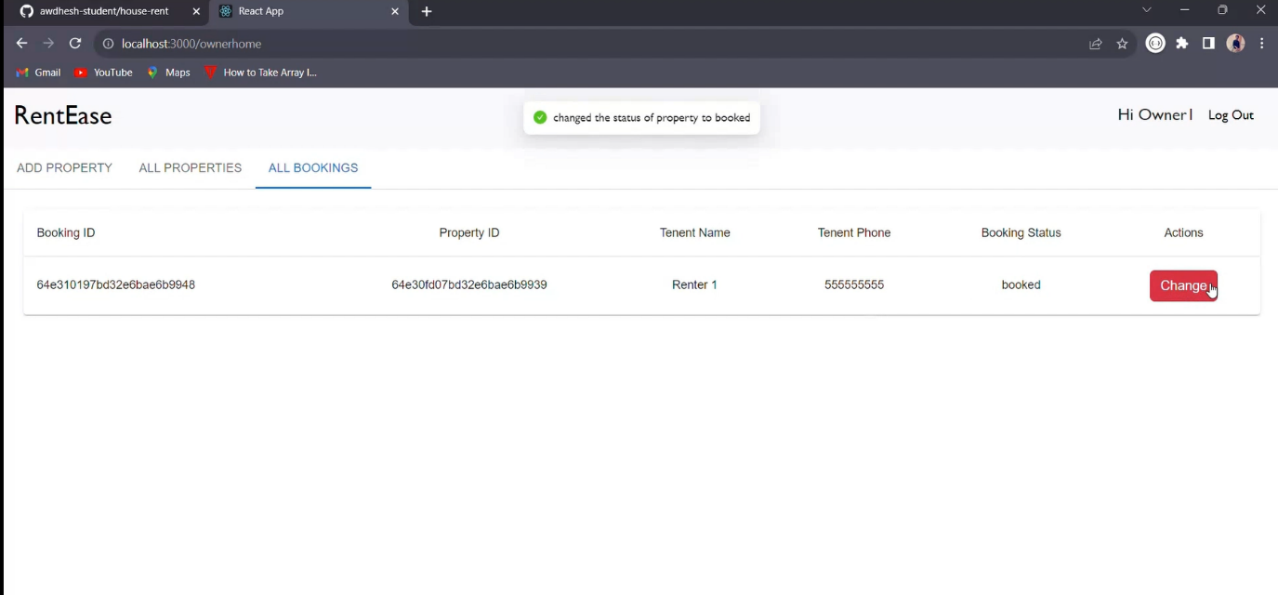

* It is used by the owner to check or authenticate whether the property price has been changed or not

### 14.2 AUTHORIZATION :

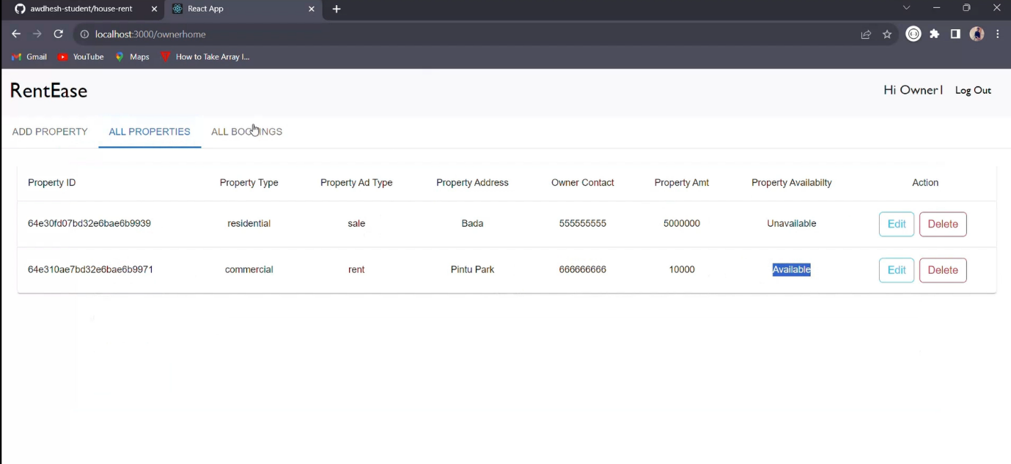

* It is used by the admin to authorize whether if the property is valid to be sold or it is already to other renter if it is then the existing property will be removed .

## 15 . DEPLOYMENT FOR BACKEND & FRONTEND :

## GIT EXPLAINATION :

Git is a **version control system (VCS)** used to track changes in files and manage source code history. It’s widely used in software development to help teams and individuals collaborate on projects, track code changes, and manage multiple versions of codebases.

Here are the core concepts and functionalities of Git:

### **1. Tracking and Versioning Code**

* Git monitors changes in files over time. This enables developers to keep a history of every change, making it easy to view, compare, or revert to previous versions.
* Every time a developer saves a change (known as a "commit"), Git records it with a unique identifier. This allows tracking the development process step-by-step.

### **2. Distributed System**

* Unlike traditional VCS that rely on a central server, Git is **distributed**. Every developer has a full copy of the project’s history on their local machine, allowing them to work offline and independently.
* This design also enhances collaboration and backup, as every user’s local repository is a complete version of the project.

### **3. Branches and Merging**

* Git allows developers to create **branches**, which are separate lines of development. For instance, one branch could be for a new feature, another for fixing bugs, and another for experimenting.
* Branching enables parallel work without interfering with the main codebase. Once changes are complete, branches can be **merged** back into the main branch, integrating all updates.

**4. Collaboration and Pull Requests**

* Git is ideal for collaborative development. Developers can contribute code, suggest changes, or review each other’s work through pull requests (on platforms like GitHub or GitLab).
* This makes it easy to organize contributions, discuss potential improvements, and ensure code quality before merging.

### **5. Commit History and Blame Tracking**

* Git records the details of each commit, including who made the change, when, and what was changed. This **commit history** allows developers to track the progress of a project, identify the source of bugs, or understand the evolution of the codebase.
* With **blame tracking**, it’s easy to trace specific lines of code to the person who last modified them, aiding in debugging and accountability.

### **6. Undoing Changes**

* Git provides options to undo changes, whether it's discarding recent modifications, restoring files to a previous state, or rolling back to an older commit. This flexibility is crucial for risk-free experimentation and development.

### **7. Staging Area**

* Git has a **staging area** where changes are listed before committing them. This area acts as a buffer, allowing developers to select specific changes to commit, group related updates, and ensure only intended changes are included.

### **Why Git is Important**

* **Efficiency**: Git handles changes quickly and effectively, even in large codebases.
* **Flexibility**: With branching and merging, Git enables flexible workflows that can adapt to various project needs.
* **Collaboration**: Git is built for teamwork, allowing multiple contributors to work simultaneously without overwriting each other’s code.

Git has become an essential tool in modern development due to its robust capabilities, flexibility, and efficiency in managing complex projects with multiple contributors.

### 15.1 BACKEND DEPLOYMENT :

### 

### 15.2 FRONTEND DEPLOYMENT :

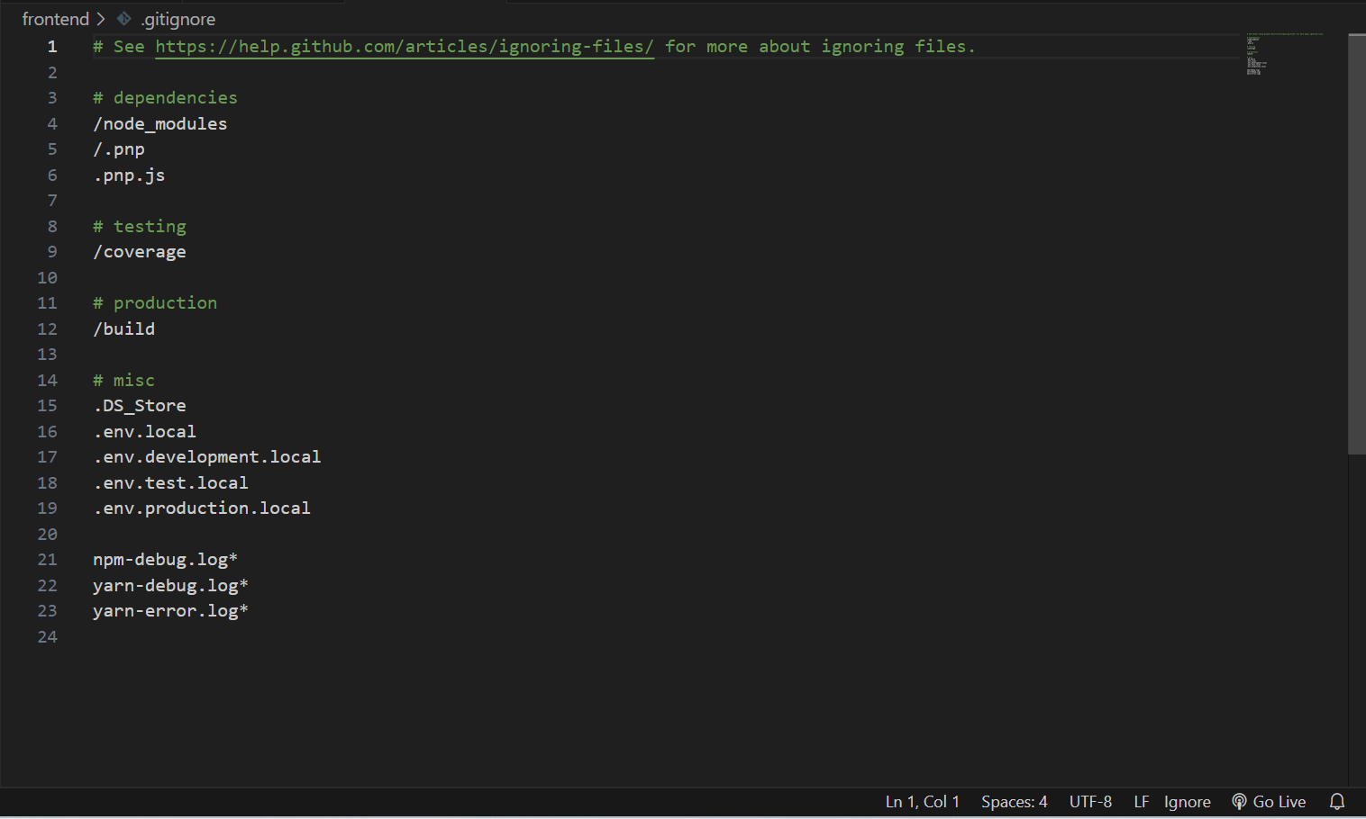

## 16 . TESTING AND QUALITY ASSURANCE :

* Testing and Quality Assurance (QA) are essential to ensure that a MERN-based house rental app runs smoothly, is secure, and offers an optimal user experience. This process covers both functional and non-functional aspects of the application, such as usability, security, and performance.

#### **1. Requirements Analysis and Test Planning**

* **Define Requirements**: Identify functional requirements (like property search, user authentication, and payment processing) and non-functional requirements (like response time and security).
* **Test Plan Creation**: Develop a comprehensive test plan that outlines test types, objectives, environments, tools, and timelines.

#### **2. Functional Testing**

* **Unit Testing**: Test individual components of the app in isolation to ensure they perform correctly. For example, testing the search bar, property listing display, and filters separately.
* **Integration Testing**: Ensure that the components work together as expected. For example, testing that the search function interacts correctly with the database to retrieve filtered listings.
* **API Testing**: Validate that the backend API endpoints (like login, property listings, and user interactions) respond correctly, handle errors, and provide accurate data to the frontend.
* **User Acceptance Testing (UAT)**: Verify with end users (both renters and property owners) to confirm that the app meets their needs and expectations.

#### **3. User Interface (UI) and Usability Testing**

* **UI Consistency**: Ensure design elements like fonts, colors, and layouts are consistent across different pages and devices.
* **Navigation and Flow Testing**: Check the ease of navigating the app, whether users can easily locate features like searching properties, applying for listings, or messaging owners.
* **Responsive Design Testing**: Test the app on various devices (e.g., mobile, tablet, and desktop) to confirm that it adapts to different screen sizes and resolutions.

#### **4. Performance Testing**

* **Load Testing**: Simulate high user traffic to evaluate how the app handles multiple users searching, messaging, and making payments simultaneously.
* **Stress Testing**: Push the app beyond its typical operational capacity to observe behavior under extreme conditions and identify breakpoints.
* **Response Time Monitoring**: Ensure the app loads listings quickly and responds to user actions (like applying filters) in an acceptable timeframe.

#### **5. Security Testing**

* **Authentication and Authorization**: Test user authentication processes to verify that only authorized users can access specific features (e.g., admin features for property owners).
* **Data Protection**: Ensure sensitive data, like personal details and payment information, is secure, using encryption and safe handling of user data.
* **Vulnerability Testing**: Identify and mitigate potential security risks, such as SQL injections, cross-site scripting (XSS), and cross-site request forgery (CSRF).

#### **6. Database Testing**

* **Data Integrity**: Ensure that data entered by users, like property listings and user profiles, is correctly saved and retrieved from MongoDB.
* **Data Consistency**: Verify that the data remains consistent across different modules and that updates (like price changes or new listings) appear instantly.

#### **7. Regression Testing**

* **Re-test Existing Features**: Run tests on previously tested functionality whenever new features are added or existing features are updated to ensure no new bugs were introduced.
* **Automated Regression Testing**: Set up automated test suites to frequently verify core functionalities, reducing manual effort and catching issues early.

#### **8. Non-Functional Testing**

* **Performance Metrics**: Measure key metrics like load times, response times, and memory usage.
* **Usability Testing**: Conduct usability testing with a sample of end-users, gathering feedback on the app’s layout, design, and ease of use.
* **Accessibility Testing**: Verify that the app is accessible to users with disabilities, ensuring compatibility with screen readers and keyboard navigation.

#### **9. Continuous Integration (CI) and Continuous Deployment (CD)**

* **Automated Testing in CI/CD Pipelines**: Integrate automated tests within the CI/CD pipeline so that code is tested each time there is a new commit. This ensures rapid detection of issues.
* **Continuous Monitoring**: Set up monitoring tools to track app health, error rates, and user behavior after deployment.

**1. Functional Test Cases**

|  |  |  |  |
| --- | --- | --- | --- |
| **Test Case ID** | **Description** | **Expected Outcome** | **Status** |
| TC_FT_01 | Verify login with valid credentials | User is redirected to the dashboard | Pass |
| TC_FT_02 | Verify search functionality | Products matching the search term are displayed | Pass |
| TC_FT_03 | Add property to existing test | Property added detailed show up | Pass |
| TC_FT_04 | Apply valid number of price | Price is applied, and final price is adjusted | Pass |
| TC_FT_05 | Verify admin can add new property for renter | New property appears on the site | Pass |

**2. Usability Test Cases**

|  |  |  |  |
| --- | --- | --- | --- |
| **Test Case ID** | **Description** | **Expected Outcome** | **Status** |
| TC_UT_01 | Verify intuitive navigation for first-time users | Users easily locate major sections (like newly updated locations and price) | Pass |
| TC_UT_02 | Test product filtering by category and price | Property filter correctly, and interface is clear | Pass |

**3. Performance Test Cases**

|  |  |  |  |
| --- | --- | --- | --- |
| **Test Case ID** | **Description** | **Expected Outcome** | **Status** |
| TC_PT_01 | Simulate 100 concurrent users on the platform | Platform performs within acceptable speed limits | Pass |
| TC_PT_02 | Test load time under peak traffic | Page load times are below 3 seconds | Pass |

**4. Security Test Cases**

|  |  |  |  |
| --- | --- | --- | --- |
| **Test Case ID** | **Description** | **Expected Outcome** | **Status** |
| TC_ST_01 | Test for SQL injection vulnerabilities | System prevents SQL injection attempts | Pass |
| TC_ST_02 | Verify password encryption | Passwords are securely hashed and stored | Pass |
| TC_ST_03 | Check for data transmission over HTTPS | All data is transmitted securely | Pass |

**5. Compatibility Test Cases**

|  |  |  |  |
| --- | --- | --- | --- |
| **Test Case ID** | **Description** | **Expected Outcome** | **Status** |
| TC_CT_01 | Verify site compatibility with Chrome | Site functions smoothly without UI issues | Pass |
| TC_CT_02 | Verify site compatibility with mobile Safari | Site is responsive and fully functional | Pass |
| TC_CT_03 | Test screen responsiveness across devices | Layout adapts correctly to desktop, tablet, mobile | Pass |

* **Overall Outcome**: Testing results were positive, confirming that the platform is robust, user-friendly, secure, and compatible across multiple devices and browsers.

## 17 . CHALLENGES AND SOLUTIONS :

* Developing a house rental app using the MERN stack comes with its own set of challenges. Below are some common challenges faced during development, along with potential solutions to address them:

### **1. Scalability**

* **Challenge**: As the number of users and properties increases, the application must efficiently handle larger amounts of data and user requests without performance degradation.
* **Solution**:
  + Implement **load balancing** to distribute incoming traffic across multiple servers.
  + Utilize **MongoDB's sharding** capabilities to split data across different databases, improving read and write performance.
  + Optimize the application code and database queries to reduce response times.

### **2. Data Consistency**

* **Challenge**: Ensuring data integrity and consistency when multiple users are making changes (e.g., updating property details or applying for rentals).
* **Solution**:
  + Use **transactions** in MongoDB for operations that require multiple document updates to ensure all changes either succeed or fail together.
  + Implement server-side validation checks to prevent data corruption and ensure all incoming data is properly formatted.

### **3. User Authentication and Security**

* **Challenge**: Protecting user data and preventing unauthorized access while ensuring a smooth login experience.
* **Solution**:
  + Use **JWT (JSON Web Tokens)** for secure, stateless authentication. This allows for easy validation and user session management.
  + Implement robust **password hashing** using libraries like bcrypt to securely store user passwords.
  + Regularly conduct **security audits** and vulnerability assessments to identify and mitigate risks.

### **4. Search and Filtering Performance**

* **Challenge**: Efficiently searching and filtering through potentially large datasets of properties can lead to slow response times.
* **Solution**:
  + Implement **indexing** in MongoDB on fields commonly queried (e.g., location, price, and property type) to speed up searches.
  + Utilize **aggregation pipelines** for complex queries that involve filtering and sorting.
  + Cache frequently accessed data using tools like Redis to reduce load on the database.

### **5. Cross-Platform Compatibility**

* **Challenge**: Ensuring the application provides a consistent experience across various devices and screen sizes.
* **Solution**:
  + Use **responsive design principles** in the frontend (e.g., with CSS frameworks like Bootstrap or Material-UI) to ensure the app adapts to different screen sizes.
  + Conduct thorough testing on multiple devices and browsers to identify and resolve compatibility issues.

### **6. User Experience (UX)**

* **Challenge**: Creating an intuitive and engaging user experience for both renters and property owners.
* **Solution**:
  + Conduct **user research** to gather insights on user needs and pain points, then iterate on design based on feedback.
  + Implement features like **real-time chat** or notifications to enhance communication between renters and property owners.
  + Utilize UI/UX design tools (e.g., Figma or Adobe XD) to prototype and test user flows before full implementation.

### **7. Payment Processing**

* **Challenge**: Implementing a secure and reliable payment system for processing rent payments and handling transactions.
* **Solution**:
  + Use established payment gateways like **Stripe or PayPal** that provide secure APIs for handling transactions and managing payment data.
  + Ensure compliance with regulations (like PCI-DSS) when handling financial transactions and user payment information.

### **8. Maintaining Code Quality**

* **Challenge**: As the application grows, maintaining clean, modular, and well-documented code becomes challenging.
* **Solution**:
  + Adopt **coding standards and best practices** across the development team, using tools like ESLint for JavaScript code quality.
  + Implement a **code review process** to ensure code changes are thoroughly vetted before being merged into the main branch.
  + Use **automated testing** frameworks (like Jest or Mocha) to regularly test code changes and maintain functionality.

### **9. Deployment and DevOps**

* **Challenge**: Managing deployment processes and maintaining uptime can be complex, especially with frequent updates.
* **Solution**:
  + Use **containerization** (e.g., Docker) to standardize the deployment environment and simplify deployment processes.
  + Implement **CI/CD pipelines** to automate testing and deployment, ensuring that changes are quickly integrated and delivered to users.
  + Monitor application performance and health using tools like New Relic or Grafana to quickly identify and resolve issues.

## 18 . FUTURE ENHANCEMENT :

* Improvement with design and layout to modern and accurate web page .
* Providing an better user experience with Artifical Intelligence and Machine Learning .
* More enchancement in number of user active accounts .

## 19 . CONCLUSION :

* The development of a house rental app utilizing the MERN stack—MongoDB, Express.js, React, and Node.js—offers a comprehensive and robust solution for connecting renters with property owners in an efficient and user-friendly manner. The MERN stack is well-suited for this application due to its flexibility, scalability, and ability to handle real-time data interactions seamlessly.
* By leveraging MongoDB as a NoSQL database, the app can effectively manage large volumes of property listings and user information while ensuring data integrity and performance. Express.js provides a lightweight and modular framework for building a scalable backend API that can handle complex requests efficiently. Node.js enhances the application’s performance with its non-blocking architecture, allowing for rapid handling of multiple user requests.
* On the frontend, React empowers developers to create an interactive and dynamic user interface, ensuring a smooth user experience. The component-based architecture of React facilitates efficient updates and state management, which is crucial for features such as real-time property listings and user notifications.
* Moreover, implementing robust security measures, intuitive navigation, and effective search and filter functionalities ensures that both renters and property owners have a seamless experience. Continuous integration and deployment practices, combined with thorough testing and quality assurance processes, further enhance the application’s reliability and performance.
* In summary, the house rental app built with the MERN stack not only addresses the current needs of the rental market but also positions itself for future growth and adaptation. By prioritizing user experience, security, and maintainability, this application stands to provide significant value to its users while fostering a vibrant community of renters and property owners.

## 20 . REFERENCE :

**1. Technical Documentation**

* Frameworks and Libraries:
  + Official documentation for React (for styling).
  + Examples:
* React installation guide: <https://reactjs.org/docs/create-a-new-react-app.html>
* Ant Design React UI library :<https://ant.design/docs/react/introduce>
* Node.js Download: <https://nodejs.org/en/download/>
* Installation instructions: <https://nodejs.org/en/download/package-manager/>
* Database Management:
  + References for databases used (MongoDB).
  + Examples:
* MongoDBDownload:<https://www.mongodb.com/try/download/community>
* Installation instructions: <https://docs.mongodb.com/manual/installation/>

**2. Books, Articles, and Tutorials**

* Books: Include books that helped guide the architectural design or backend/front-end development practices. For example:
  + "JavaScript: The Good Parts" by Douglas Crockford for JavaScript best practices.
  + "Designing Data-Intensive Applications" by Martin Kleppmann for database and scalability strategies.
* Online Articles:
  + Articles or blog posts on implementing performance optimization, scaling e-commerce platforms, or best practices in UX design for web applications.

**3. Industry Standards and Best Practices**

* User Experience:
  + Guidelines on UX best practices, such as Nielsen Norman Group or Material Design by Google, can be cited if they influenced your design.
  + Example:
    - Nielsen Norman Group: <https://www.nngroup.com/articles/>
* Performance Optimization and CDN Use:
  + Guides and industry benchmarks from Google Lighthouse or Web.dev for front-end performance and mobile responsiveness.
  + Example:
    - Web.dev (Google): <https://web.dev/>